2) Example Facebook Posts
“Do you help to look after a family member or friend who would struggle without your support because of their illness, frailty, disability, mental health problem or addiction? If so, you are a carer. Contact reception to find out how we can support you.”
“Do you help to look after a family member or friend who would struggle without your support because of their illness, frailty, disability, mental health problem or addiction? If so, you are a carer. Check out www.carerssupport.org.uk and see how they can support you.”
“Do you know someone who helps to look after a family member or friend who would struggle without their support because of illness, frailty, disability, mental health problem or addiction? If so, they are a carer. Help them connect with www.carerssupport.org.uk and see what support is available.”

Example images for Facebook Posts
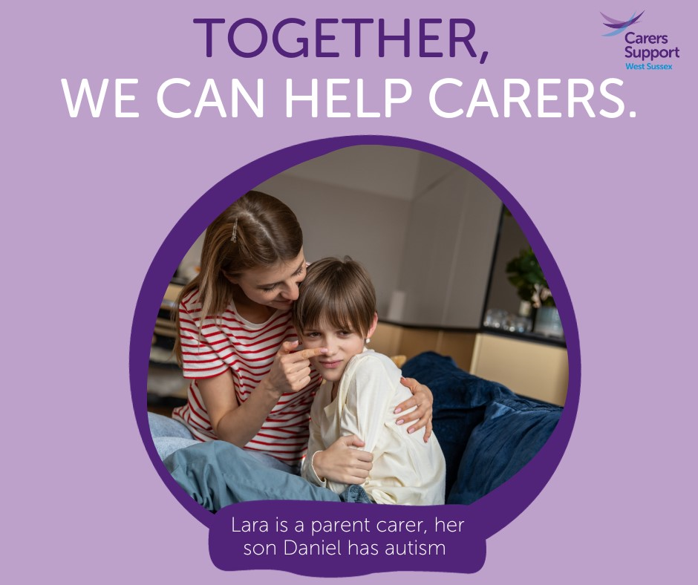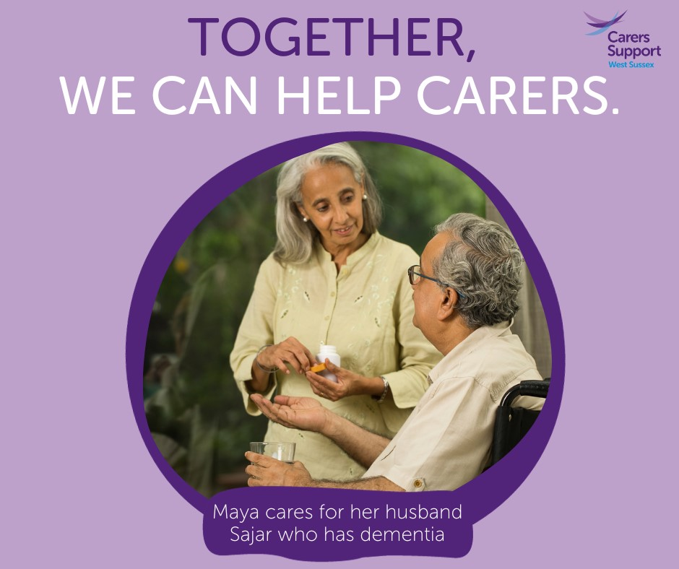
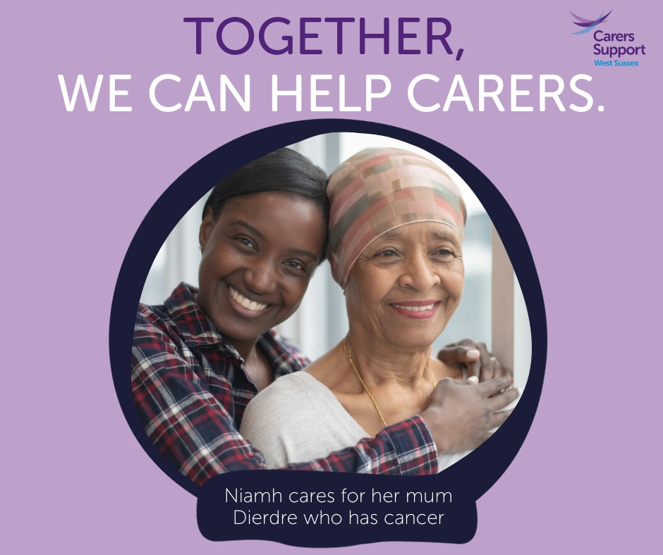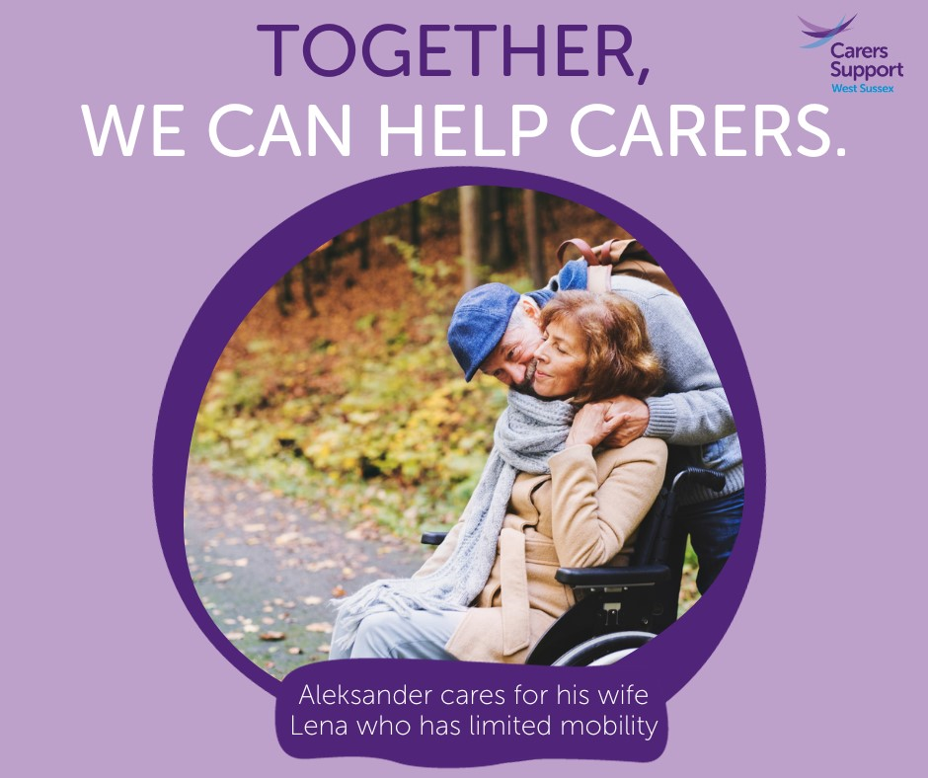
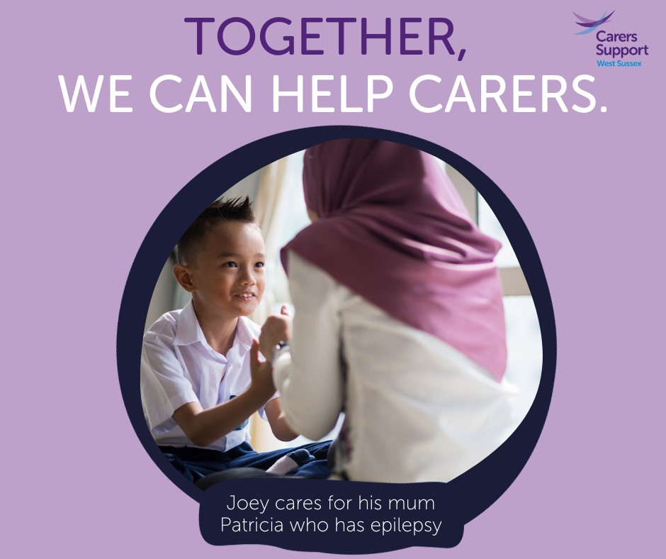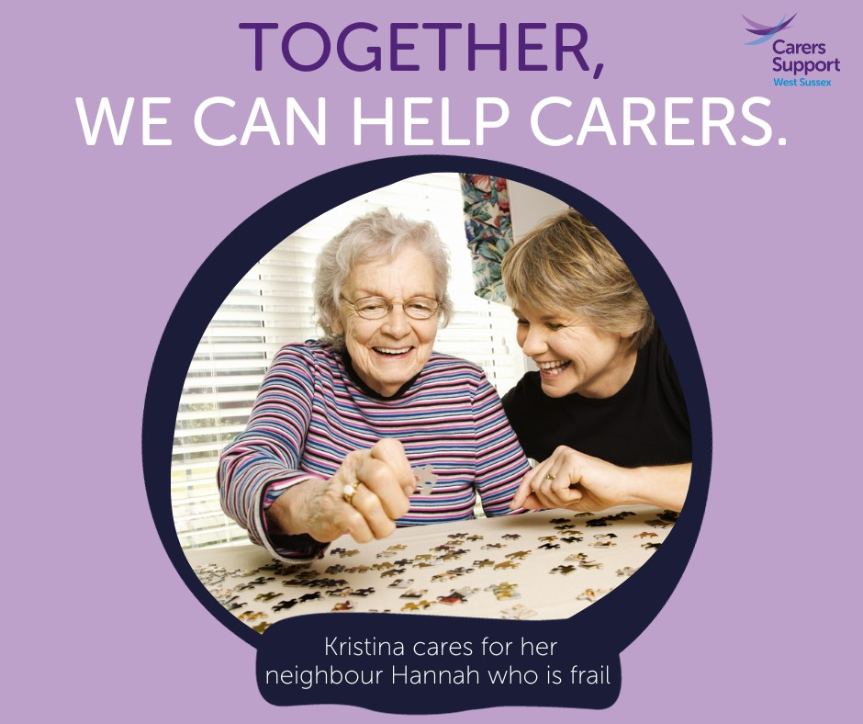

Flu Facebook post
Free flu vaccinations for carers
Do you help to look after a family member or friend who would struggle without your support because of their illness, frailty, disability, mental health problem or addiction? If so, you are a carer.
You are eligible for a free flu vaccination if you are any of the following:
- the main carer for a disabled person
- the main carer for a person over 65 years old
- in receipt of carers allowance

Call the surgery to book yours now.

(available images for use below)
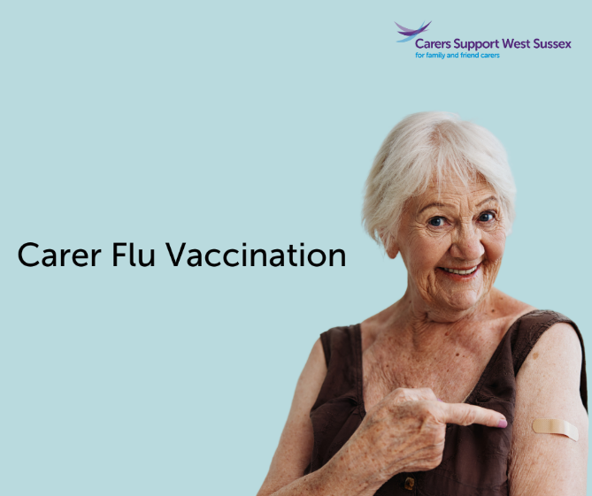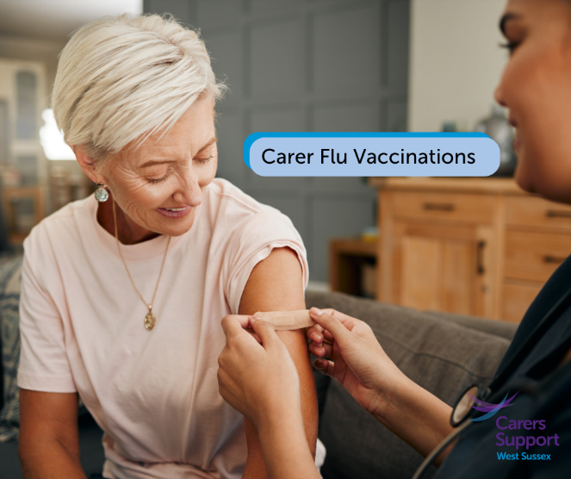
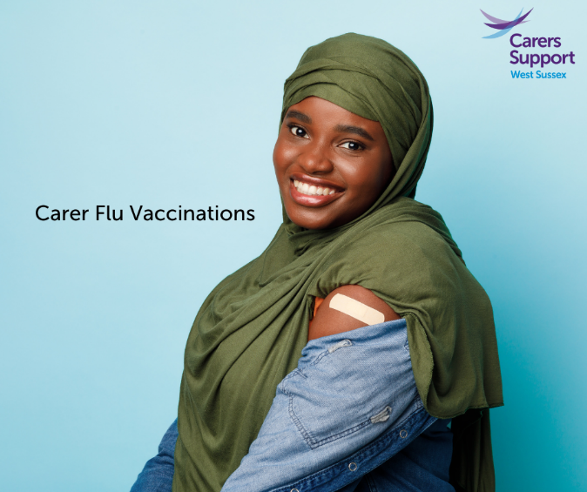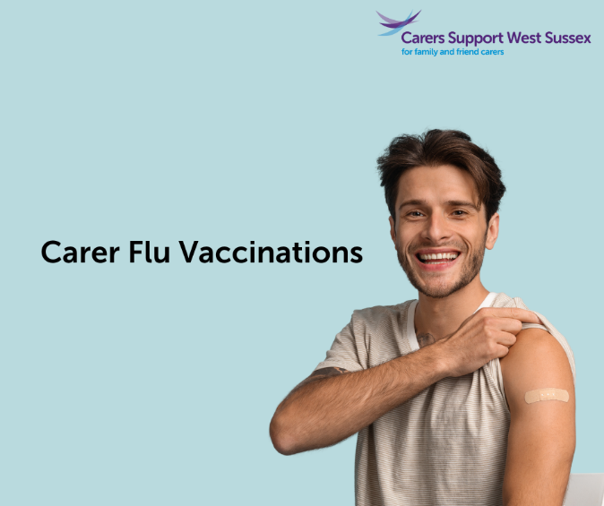
- Website text
Free flu vaccinations for carers
Do you help to look after a family member or friend who would struggle without your support because of their illness, frailty, disability, mental health problem or addiction? If so, you are a carer.

You are eligible for a free flu vaccination if you are any of the following:
- the main carer for a disabled person
- the main carer for a person over 65 years old
- in receipt of carers allowance

Call the surgery to book yours now.
The flu vaccination is safe and effective. It's offered every year through the NHS to help protect people at risk of getting seriously ill from flu. Please see the link for more information Flu vaccine - NHS (www.nhs.uk) or check out this simple information leaflet here

- Facebook post
Free Covid Booster vaccinations for carers
Do you help to look after a family member or friend who would struggle without your support because of their illness, frailty, disability, mental health problem or addiction? If so, you are a carer.
You are eligible for a free covid vaccination if you are any of the following:
- 16 or over and the sole or primary carer of an elderly or disabled person who is at increased risk of COVID-19 mortality and therefore clinically vulnerable.
- Eligible for Carers Allowance

Call the surgery to book yours now.

(available images for use below)
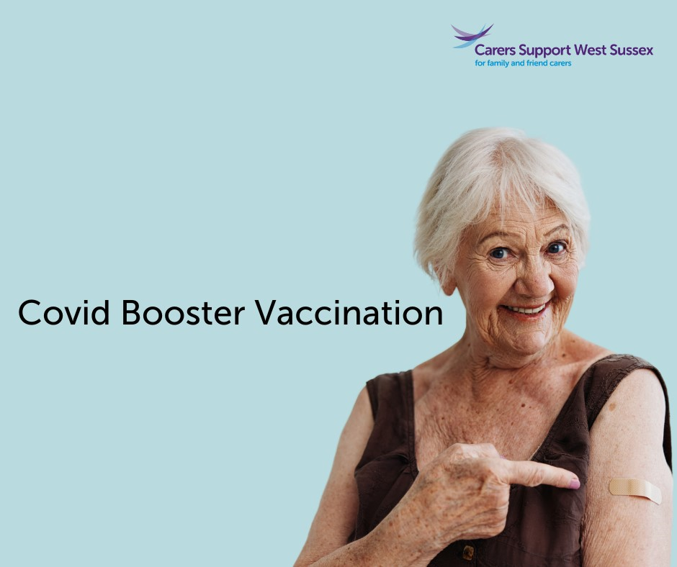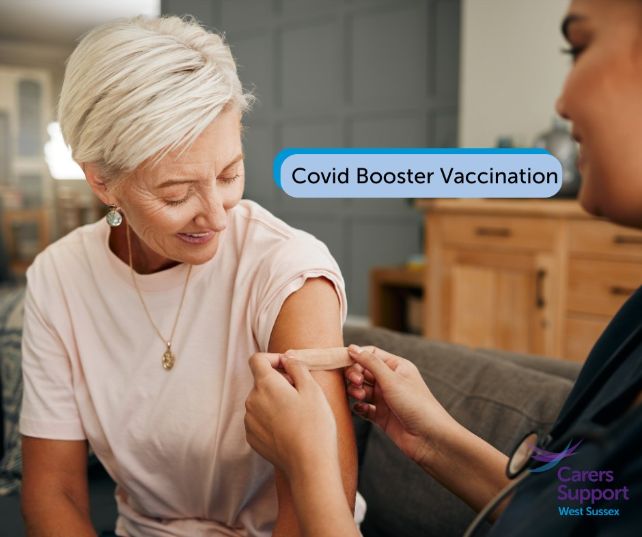
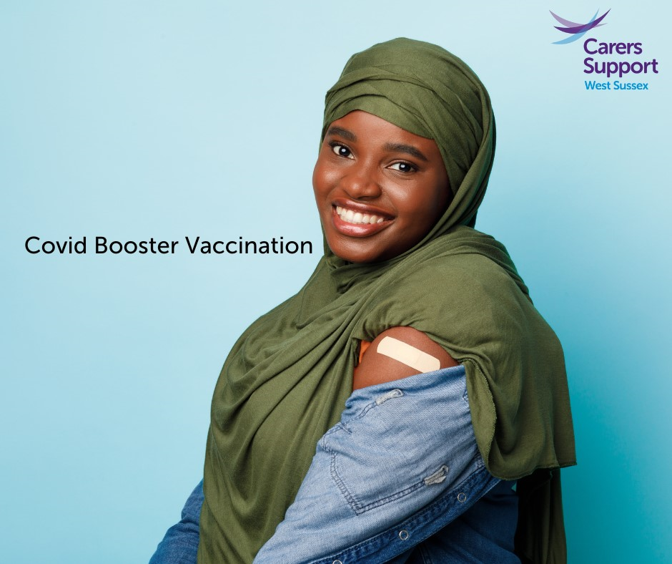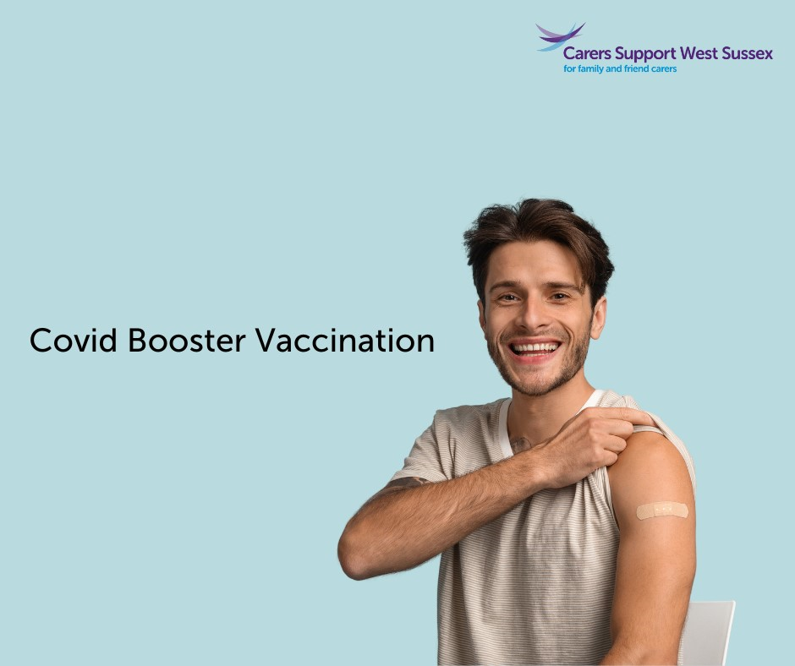

- Website text
Free Covid Booster vaccinations for carers
Do you help to look after a family member or friend who would struggle without your support because of their illness, frailty, disability, mental health problem or addiction? If so, you are a carer.
You are eligible for a free covid vaccination if you are any of the following:
- 16 or over and the sole or primary carer of an elderly or disabled person who is at increased risk of COVID-19 mortality and therefore clinically vulnerable.
- Eligible for Carers Allowance

Call the surgery to book yours now.

